BurnDown chart:

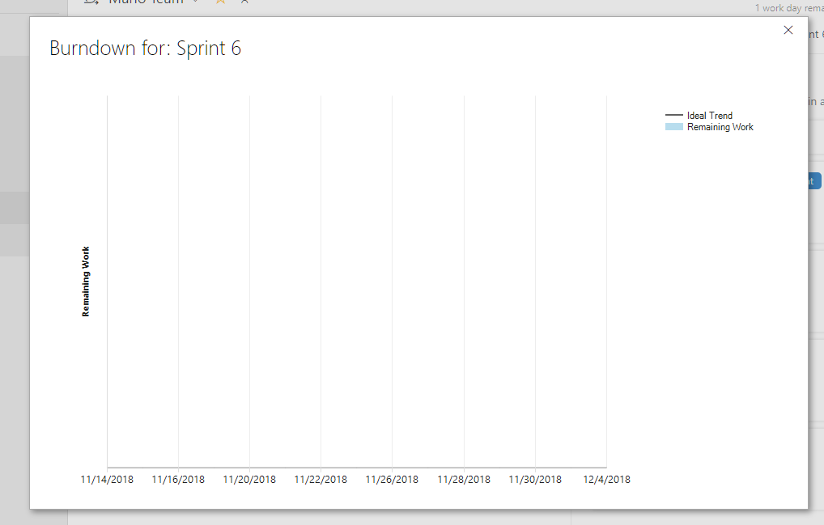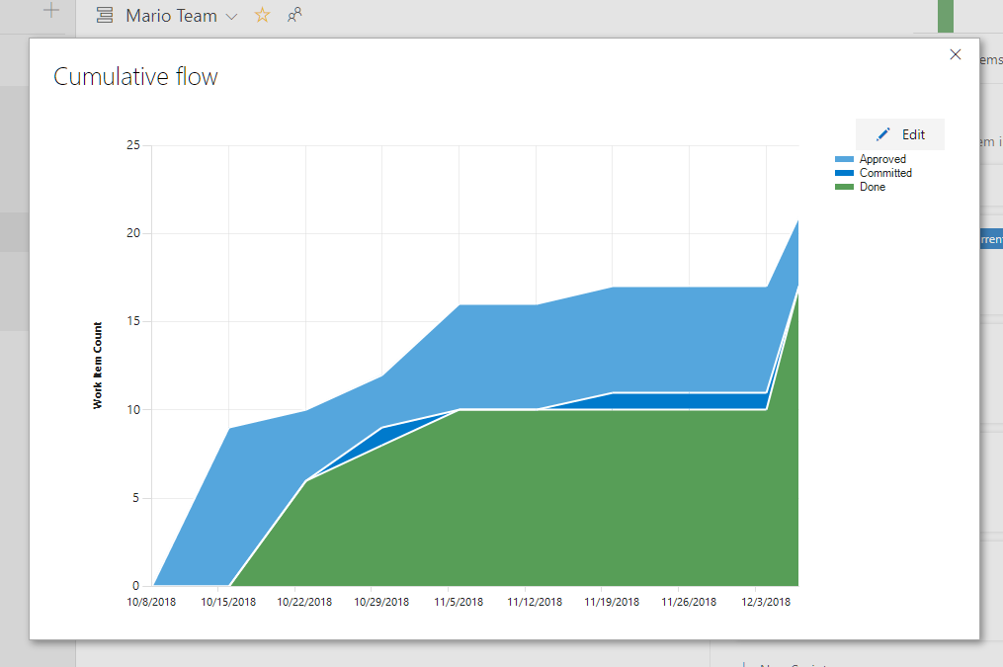

For this time, the burn down chart get some problem, maybe some setting problem on it, then it causes some problem. However, we actually follow the requirement, from the Cumulate flow, you can find we set and finish our process day by day. We average the workload and try to finish it as soon as possible. The only problem of the burndown charts for this time is the setting problem. Since the VSTS has changed a lot, I am a little confuse about the setting. But I am quite sure that arrange certain time on each task and set the state as “In progress”. It looks weird that our burndown char gets the problem. I think I need do some research on that to make sure the problem would not happen in the future.

However, although the burndown chart does not work, I find another graph called “Cumulative flow” which can reflect our work progress. From that chart, you can find that after certain of the day, we add new task and finish certain tasks. However, on the middle of the work period, we come across problem since we are stuck with shuffle the endless level and the planning of the mini boss. So that cause some problems. But after that tough days, things become better and we finally finished all the work.